A Project Report on

COLLEGE HOSTEL BOOKING SYSTEM

Submitted in partial fulfillment of requirements for the award of the course of
EGB1201–JAVAPROGRAMMING

Under the guidance of

Dr.R.BHARATHI M.E.,PhD.,

Associate Professor/IT

SubmittedBy

SRIMUGHI G (927624BEE097)

DEPARTMENT OF ELECTRICAL AND ELECTRONICS ENGINEERING

M.KUMARASAMY COLLEGE OF ENGINEERING
(Autonomous)
KARUR–639113
DECEMBER 2025

M.KUMARASAMY COLLEGE OF ENGINEERING
(Autonomous Institution affiliated to Anna University,Chennai)

KARUR–639113

BONAFIDE CERTIFICATE

Certified that this projec treport on “COLLEGE HOSTEL BOOKING SYSTEM” is the bonafide work of SRIMUGHI G (927624BEE097) who carried out the project work during the academic year 2024 - 2025 under my supervision.

Signature | Signature
Dr.R.BHARATHI M.E.,PhD., | Dr.J.UMA M.E.,Ph.D.,
SUPERVISOR, | HEAD OF THE DEPARTMENT,
Department of Information Technology | Department of Electrical and Electronics Engineering,
M.Kumarasamy College of Engineering, | M.Kumarasamy College of Engineering,
Thalavapalayam,Karur-639113. | Thalavapalayam,Karur-639113.

DEPARTMENT OF ELECTRICAL AND ELECTRONICS`ENGINEERING
VISIONOF THE INSTITUTION
- To emerge as a leader among the top institutions in the field of technical education
MISSIONOF THE INSTITUTION
- Produces mart technocrats with empirical knowledge who cansurmount the global Challenges.
- Create a diverse, fully-engaged, learner - centric campus environment to provideQuality education to the students.
- Maintainmutuallybeneficialpartnershipswithouralumni,industry,andProfessional associations.
VISION OF THE DEPARTMENT

To create competent Electrical and Electronics Engineers who will work in Emerging technologies thereby contributing value to their career and society
MISSIONOF THE DEPARTMENT
- DM1: Impart quality education to enhance knowledge and skills in emerging technologies.
- DM2: Create an innovation and product development ecosystem in core and Interdisciplinary Industrial applications leading to patents.
- DM3: Augment student core competency and soft skills in handling technical projects.
PROGRAM EDUCATIONAL OBJECTIVES (PEOs)

- PEO 1: Core Engineering Proficiency: Apply strong fundamentals in electrical and electronics engineering to solve complex problems in power systems, drives and instrumentation.
- PEO 2: Research and Emerging Technologies: Pursue research and adopt emerging technologies to innovate in core and interdisciplinary domains.
- PEO 3:Industry Readiness: Demonstrate technical and professional skills for successful careers in industry and entrepreneurship.
- PEO 4: Ethics and Societal Responsibility: Practice engineering with ethics, sustainability and a commitment to societal well-being.
PEO5:Lifelong Learning and Global Competence: Engage in continuous learning and adapt to globaltechnologicaladvancements.

PROGRAM OUTCOMES (POs)

Engineering students will be able to:
- Engineering knowledge: Apply the knowledge of mathematics, science, engineering fundamentals,andanengineeringspecializationtothesolutionofcomplexengineeringproblems.
- Problem analysis: Identify, formulate, review research literature, and analyze complex engineering problems reaching substantiated conclusions using first principles of mathematics, natural sciences, and engineering sciences.
- Design/development of solutions: Design creative solutions for complex engineering problems and design/develop systems/components/processes to meet identified needs with consideration for the public health and safety, whole-life cost, net zero carbon, culture, society and environment as required.
- Conduct investigations of complex problems: Conduct investigations of complex engineering problems using research-based knowledge including design of experiments, modelling, analysis & interpretation of data to provide valid conclusions.
- Engineering tool usage: Create, select and apply appropriate techniques, resources and modern engineering & IT tools, including prediction and modelling recognizing their limitations to solve complex engineering problems.
- The Engineer and The World: Analyze and evaluate societal and environmental aspects while solving complex engineering problems for its impact on sustainability with reference to economy, health, safety, legal framework, culture and environment.
- Ethics:Apply ethical principles and commit to professional ethics, human values, diversity and inclusion; adhere to national & international laws.
- Individual and Collaborative team work: Function effectively as an individual, and as a member or leader in diverse/multi-disciplinary teams.
- Communication: Communicate effectively and inclusively within the engineering community and society at large, such as being able to comprehend and write effective reports and design documentation, make effective presentations considering cultural, language, and learning differences.

- Project management and finance: Apply knowledge and understanding of engineering management principles and economic decision-making and apply these to one’s own work, as a member and leader in a team, and to manage projects and in multidisciplinary environments.
- Life-long learning: Recognize the need for, and have the preparation and ability for i) independent and life-long learning ii) adaptability to new and emerging technologies and iii) critical thinking in the broadest context of technological change.
PROGRAM SPECIFIC OUTCOMES(PSOs)

- PSO1: Power Systems Engineering:Apply comprehensive knowledge of electrical power systems to analyze, design and manage generation, transmission, and distribution networks, integrating emerging technologies and sustainable practices to contribute effectively to industry and societal needs.
- PSO2:Power Electronics and Drives:Design and develop efficient, reliable power electronic systems and motor drives with an emphasis on sustainable energy use, and inclusive technology solutions that address societal and environmental challenges.
- PSO3: Electronics and Instrumentation Engineering:Develop intelligent instrumentation and embedded systems for accurate measurements, monitoring and control in interdisciplinary domains addressing societal need

ABSTRACT

The College Hostel Booking System is a Java-based application designed to automate the process of booking hostel rooms for students. The system allows students to view available rooms, book rooms, and manage their profiles while enabling the hostel administration to efficiently manage room availability, monitor bookings, and generate reports.This project reduces manual paperwork, eliminates errors, and improves overall
efficiency.

ABSTRACT WITH POs AND PSOs MAPPING

ABSTRACT | POs  MAPPED | PSOs  MAPPED
- The College Hostel Booking System aims to hostel room booking using Java.  - Students can register,login,check available rooms and apply for hostel accommodation.  - The admin can update room details, approve or reject bookings, and track occupancy.  - This system helps reduce manual work and saves time for hostel staff and students.  - The main goal is to make the booking process easy, fast and transparent. | PO-1 PO-2 PO-3 PO-4 PO-5 PO-7 PO-8 PO-9 PO-10 PO-11 | PSO-1 PSO-2
Note:1-Low,2-Medium,3- High

SUPERVISOR HEAD OF THE DEPARTMENT

TABLE OF CONTENTS

CHAPTER  No. | TITLE | PAGE  No.
 | ABSTRACT | vi
1 | INTRODUCTION | 1
 | 1.1 Objective | 1
 | 1.2 Overview | 1
 | 1.3 Java Programming concepts | 2
2 | PROJECT METHODOLOGY | 3
 | 2.1 Proposed Work | 3
 | 2.2 Block Diagram | 4
3 | MODULEDESCRIPTION | 5
 | 3.1 User Management | 5
 | 3.2 Room Management | 5
 | 3.3 Booking Module | 5
 | 3.4 AdminPanel | 6
 | 3.5 Check out | 6
4 | RESULTS AND DISCUSSION | 7
5 | CONCLUSION | 9
 | REFERENCES | 10
 | APPENDIX | 11

  - Objective

CHAPTER 1 INTRODUCTION
To provide a user-friendly interface for hostel room booking.
To allow students to search and reserve available rooms online.
To enable administrators to manage room allocations and occupancy efficiently.
To implement secure login and authentication for students and admins.
To generate reports on bookings, vacancies, and student details.

Overview

Manual hostel room allocation is time-consuming, prone to errors, and often results in double bookings or conflicts. This system automates the process, allowing students to book rooms online and administrators to manage room data effectively.

The system ensures:

- Accurate tracking of room availability

- Real-time booking confirmation

- Ease of access and management for students and administrators

Java Programming Concepts
This project is developed using Java, applying the following OOP concepts:
  - Classes and Objects:
- Each module like Student, Room, Booking is represented as a class.
  - Inheritance:
- Admin and Student classes inherit from a common User class.
  - Polymorphism:
- Method overloading for handling different booking types.
  - Encapsulation:
- Private variables with getter and setter methods for data security.
  - Exception Handling:
- For invalid inputs and database connectivity errors.

CHAPTER 2 PROJECT METHODOLOGY

Proposed Work

The system consists of two main user roles:
  - Student and Admin.

Student:
- Can register, login, view available rooms, book a room, and view booking history.
Admin:
- Can login, add/remove rooms, view all bookings, manage student records, and generate occupancy reports.

Features include:

- Secure login and authentication
- Real-time room availability tracking
- Booking confirmation and cancellation
- Report generation for admin

Block Diagram

  - User Management:

CHAPTER 3 MODULE DESCRIPTION

- Handles student registration, login, and profile management
- Admin can add, edit, or delete student records
- Validates user input to maintain data integrity

Room Management:

Admin can add new rooms, remove rooms, and update room availability

Room details include type, number, and occupancy status

System prevents double booking of the same room

Booking Module:

- Students can view available rooms and book a room online

- Booking confirmation is stored in the database

- Students can cancel bookings or view their booking history

AdminPanel:

Admin can view all bookings and manage room allocations

Generate reports on occupancy, vacant rooms, and student information

Provides complete control over the system

Checkout:

- Students can check out of their rooms

- Admin updates room status to available for future bookings

- System maintains records of all past bookings for reporting purpos

LOGIN PAGE :

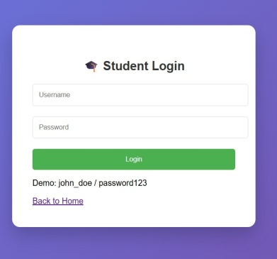

HOME PAGE:

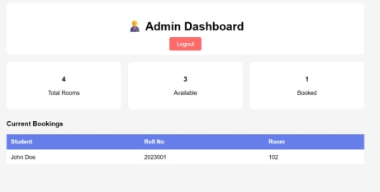

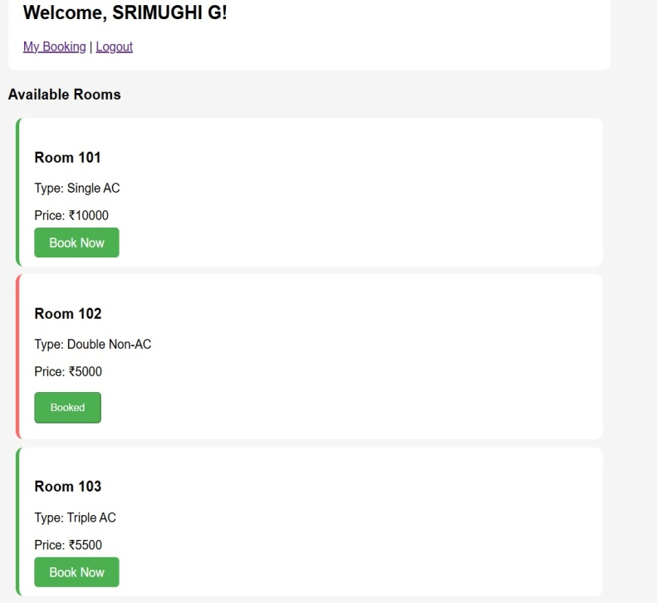

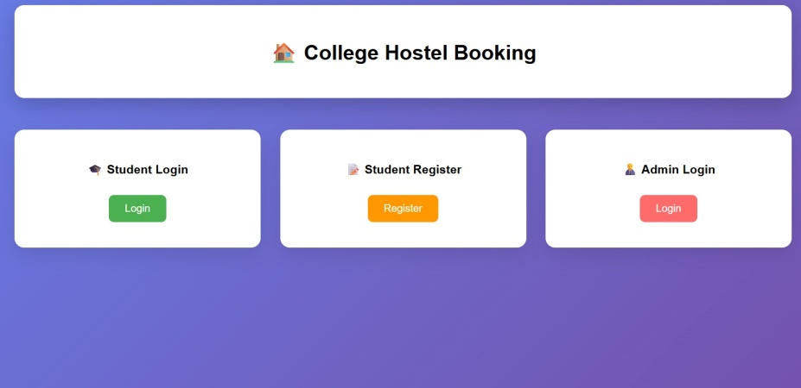

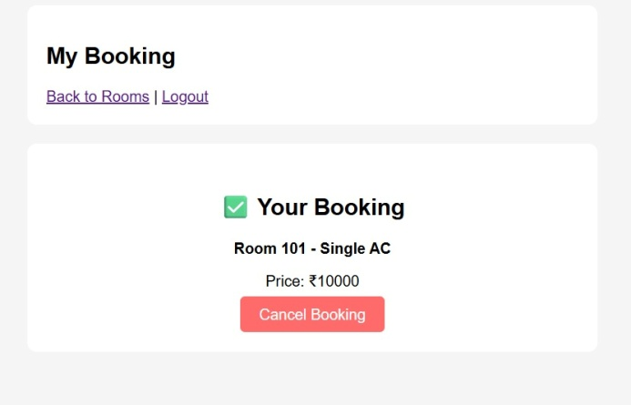

CHAPTER 4

RESULTS AND DISCUSSION

- The system successfully automates hostel room booking and management

- Students can book rooms quickly and securely

- Admins can monitor room occupancy and generate reports easily

- Error handling ensures invalid entries are rejected

- Manual errors like double booking are eliminated

CHAPTER 5 CONCLUSION

The College Hostel Booking System demonstrates how Java can be used to develop
efficient, secure, and user-friendly applications. It reduces manual effort, prevents
errors, and provides a reliable platform for both students and administrators.

Future enhancements could include:

- Mobile application for room booking

- Integration with online payment gateways

- Notification system for booking confirmations and reminders

REFERENCES:

1. Herbert Schildt, Java: The Complete Reference, McGraw-Hill, 2018.

2. Oracle Java Documentation, https://docs.oracle.com/javase/

3. JDBC Tutorials: https://www.javatpoint.com/java-jdbc

4. Swing GUI Programming Tutorials

5. MySQL Database Documentation

APPENDIX

import com.sun.net.httpserver.HttpServer;
import com.sun.net.httpserver.HttpHandler;
import com.sun.net.httpserver.HttpExchange;
import java.io.*;
import java.net.InetSocketAddress;
import java.util.*;
import java.nio.charset.StandardCharsets;

public class CollegeHostelSystem {

private static List<Room> rooms = new ArrayList<>();
private static List<Student> students = new ArrayList<>();
private static Map<String, String> bookings = new HashMap<>();
private static Map<String, String> sessions = new HashMap<>();

public static void main(String[] args) throws IOException {
initializeData();

HttpServer server = HttpServer.create(new InetSocketAddress(8080), 0);

server.createContext("/", new HomeHandler());
server.createContext("/student-login", new StudentLoginHandler());
server.createContext("/student-register", new StudentRegisterHandler());
server.createContext("/admin-login", new AdminLoginHandler());
server.createContext("/room-list", new RoomListHandler());
server.createContext("/book-room", new BookRoomHandler());
server.createContext("/my-booking", new MyBookingHandler());
server.createContext("/cancel-booking", new CancelBookingHandler());
server.createContext("/admin-dashboard", new AdminDashboardHandler());
server.createContext("/logout", new LogoutHandler());
server.createContext("/login-student", new LoginStudentHandler());
server.createContext("/login-admin", new LoginAdminHandler());
server.createContext("/register-student", new RegisterStudentHandler());

server.setExecutor(null);
server.start();

System.out.println("🚀 College Hostel Booking System Started!");
System.out.println("🌐 Open: http://localhost:8080");
System.out.println("🎓 Student: john_doe / password123");
System.out.println("👨‍💼 Admin: admin / 12345");
}

static void initializeData() {
rooms.add(new Room(101, "Single", "AC", true));
rooms.add(new Room(102, "Double", "Non-AC", true));
rooms.add(new Room(103, "Triple", "AC", true));
rooms.add(new Room(104, "Single", "Non-AC", true));

students.add(new Student("john_doe", "password123", "John Doe", "2023001", "Computer Science"));
}

// Utility methods
private static void sendHtmlResponse(HttpExchange exchange, String html) throws IOException {
exchange.getResponseHeaders().set("Content-Type", "text/html; charset=UTF-8");
exchange.sendResponseHeaders(200, html.getBytes(StandardCharsets.UTF_8).length);
OutputStream os = exchange.getResponseBody();
os.write(html.getBytes(StandardCharsets.UTF_8));
os.close();
}

private static void sendRedirect(HttpExchange exchange, String location) throws IOException {
exchange.getResponseHeaders().set("Location", location);
exchange.sendResponseHeaders(302, -1);
}

private static String getSessionId(HttpExchange exchange) {
String cookie = exchange.getRequestHeaders().getFirst("Cookie");
if (cookie != null && cookie.contains("sessionId=")) {
return cookie.substring(cookie.indexOf("sessionId=") + 10,
cookie.indexOf(";", cookie.indexOf("sessionId=")) > 0 ?
cookie.indexOf(";", cookie.indexOf("sessionId=")) : cookie.length());
}
return null;
}

private static void setSessionCookie(HttpExchange exchange, String sessionId) {
exchange.getResponseHeaders().add("Set-Cookie", "sessionId=" + sessionId + "; Path=/");
}

private static Map<String, String> parseFormData(String formData) {
Map<String, String> params = new HashMap<>();
for (String pair : formData.split("&")) {
String[] keyValue = pair.split("=");
if (keyValue.length == 2) {
params.put(keyValue[0], java.net.URLDecoder.decode(keyValue[1], StandardCharsets.UTF_8));
}
}
return params;
}

private static Student authenticateStudent(String username, String password) {
for (Student student : students) {
if (student.getUsername().equals(username) && student.getPassword().equals(password)) {
return student;
}
}
return null;
}

private static Student findStudentByUsername(String username) {
for (Student student : students) {
if (student.getUsername().equals(username)) {
return student;
}
}
return null;
}

private static Room findRoomByNumber(int roomNo) {
for (Room room : rooms) {
if (room.getRoomNo() == roomNo) {
return room;
}
}
return null;
}

private static String calculatePrice(Room room) {
int basePrice = 0;
switch (room.getSharingType()) {
case "Single": basePrice = 8000; break;
case "Double": basePrice = 5000; break;
case "Triple": basePrice = 3500; break;
}
if ("AC".equals(room.getAcType())) {
basePrice += 2000;
}
return "₹" + basePrice;
}

// Handlers
static class HomeHandler implements HttpHandler {
public void handle(HttpExchange exchange) throws IOException {
String html = "<!DOCTYPE html><html><head><title>College Hostel Booking</title><style>" +
"body{font-family:Arial;margin:0;padding:0;background:linear-gradient(135deg,#667eea 0%,#764ba2 100%);min-height:100vh;}" +
".container{max-width:1200px;margin:0 auto;padding:20px;}" +
".header{background:white;padding:30px;border-radius:15px;box-shadow:0 10px 30px rgba(0,0,0,0.2);margin-bottom:40px;text-align:center;}" +
".card-container{display:grid;grid-template-columns:repeat(auto-fit,minmax(300px,1fr));gap:30px;margin-top:50px;}" +
".card{background:white;padding:30px;border-radius:15px;box-shadow:0 10px 30px rgba(0,0,0,0.1);text-align:center;}" +
".btn{display:inline-block;padding:12px 25px;background:#667eea;color:white;text-decoration:none;border-radius:8px;margin:10px;}" +
".btn-student{background:#4CAF50;}.btn-register{background:#ff9800;}.btn-admin{background:#ff6b6b;}" +
"</style></head><body><div class='container'><div class='header'><h1>🏠 College Hostel Booking</h1></div>" +
"<div class='card-container'><div class='card'><h3>🎓 Student Login</h3><a href='/student-login' class='btn btn-student'>Login</a></div>" +
"<div class='card'><h3>📝 Student Register</h3><a href='/student-register' class='btn btn-register'>Register</a></div>" +
"<div class='card'><h3>👨‍💼 Admin Login</h3><a href='/admin-login' class='btn btn-admin'>Login</a></div></div></div></body></html>";
sendHtmlResponse(exchange, html);
}
}

static class StudentLoginHandler implements HttpHandler {
public void handle(HttpExchange exchange) throws IOException {
String html = "<!DOCTYPE html><html><head><title>Student Login</title><style>" +
"body{font-family:Arial;background:linear-gradient(135deg,#667eea 0%,#764ba2 100%);margin:0;display:flex;justify-content:center;align-items:center;min-height:100vh;}" +
".login-container{background:white;padding:40px;border-radius:15px;box-shadow:0 15px 35px rgba(0,0,0,0.2);width:100%;max-width:400px;}" +
"h2{text-align:center;color:#333;}.form-group{margin-bottom:20px;}input{width:100%;padding:12px;border:1px solid #ddd;border-radius:5px;}" +
".btn{width:100%;padding:12px;background:#4CAF50;color:white;border:none;border-radius:5px;cursor:pointer;}" +
"</style></head><body><div class='login-container'><h2>🎓 Student Login</h2>" +
"<form method='POST' action='/login-student'><div class='form-group'><input type='text' name='username' placeholder='Username' required></div>" +
"<div class='form-group'><input type='password' name='password' placeholder='Password' required></div>" +
"<button type='submit' class='btn'>Login</button></form><p>Demo: john_doe / password123</p>" +
"<a href='/'>Back to Home</a></div></body></html>";
sendHtmlResponse(exchange, html);
}
}

static class StudentRegisterHandler implements HttpHandler {
public void handle(HttpExchange exchange) throws IOException {
String html = "<!DOCTYPE html><html><head><title>Student Register</title><style>" +
"body{font-family:Arial;background:linear-gradient(135deg,#ff9800 0%,#e68900 100%);margin:0;display:flex;justify-content:center;align-items:center;min-height:100vh;}" +
".form-container{background:white;padding:40px;border-radius:15px;box-shadow:0 15px 35px rgba(0,0,0,0.2);width:100%;max-width:400px;}" +
"h2{text-align:center;color:#333;}.form-group{margin-bottom:15px;}input{width:100%;padding:10px;border:1px solid #ddd;border-radius:5px;}" +
".btn{width:100%;padding:12px;background:#ff9800;color:white;border:none;border-radius:5px;cursor:pointer;}" +
"</style></head><body><div class='form-container'><h2>📝 Student Register</h2>" +
"<form method='POST' action='/register-student'><div class='form-group'><input type='text' name='name' placeholder='Full Name' required></div>" +
"<div class='form-group'><input type='text' name='username' placeholder='Username' required></div>" +
"<div class='form-group'><input type='text' name='rollNo' placeholder='Roll Number' required></div>" +
"<div class='form-group'><input type='text' name='department' placeholder='Department' required></div>" +
"<div class='form-group'><input type='password' name='password' placeholder='Password' required></div>" +
"<button type='submit' class='btn'>Register</button></form><a href='/'>Back to Home</a></div></body></html>";
sendHtmlResponse(exchange, html);
}
}

static class RoomListHandler implements HttpHandler {
public void handle(HttpExchange exchange) throws IOException {
String sessionId = getSessionId(exchange);
String studentUsername = sessions.get(sessionId);

if (studentUsername == null) {
sendRedirect(exchange, "/student-login");
return;
}

Student student = findStudentByUsername(studentUsername);
StringBuilder roomCards = new StringBuilder();

for (Room room : rooms) {
String button = room.isAvailable() ?
"<a href='/book-room?room=" + room.getRoomNo() + "' class='btn'>Book Now</a>" :
"<button class='btn' disabled>Booked</button>";

roomCards.append("<div style='background:white;padding:20px;margin:10px;border-radius:10px;border-left:5px solid " +
(room.isAvailable() ? "#4CAF50" : "#ff6b6b") + ";'><h3>Room " + room.getRoomNo() + "</h3>" +
"<p>Type: " + room.getSharingType() + " " + room.getAcType() + "</p>" +
"<p>Price: " + calculatePrice(room) + "</p>" + button + "</div>");
}

String html = "<!DOCTYPE html><html><head><title>Available Rooms</title><style>" +
"body{font-family:Arial;margin:0;padding:20px;background:#f5f5f5;}.container{max-width:800px;margin:0 auto;}" +
".header{background:white;padding:20px;border-radius:10px;margin-bottom:20px;}.btn{padding:10px 20px;background:#4CAF50;color:white;text-decoration:none;border-radius:5px;}" +
"</style></head><body><div class='container'><div class='header'><h2>Welcome, " +
(student != null ? student.getName() : "Student") + "!</h2><a href='/my-booking'>My Booking</a> | <a href='/logout'>Logout</a></div>" +
"<h3>Available Rooms</h3>" + roomCards.toString() + "</div></body></html>";

sendHtmlResponse(exchange, html);
}
}

static class MyBookingHandler implements HttpHandler {
public void handle(HttpExchange exchange) throws IOException {
String sessionId = getSessionId(exchange);
String studentUsername = sessions.get(sessionId);

if (studentUsername == null) {
sendRedirect(exchange, "/student-login");
return;
}

Student student = findStudentByUsername(studentUsername);
String roomNo = bookings.get(studentUsername);
String bookingContent;

if (roomNo != null) {
Room room = findRoomByNumber(Integer.parseInt(roomNo));
bookingContent = "<div style='background:white;padding:30px;border-radius:10px;text-align:center;'><h2>✅ Your Booking</h2>" +
"<p><strong>Room " + roomNo + " - " + room.getSharingType() + " " + room.getAcType() + "</strong></p>" +
"<p>Price: " + calculatePrice(room) + "</p>" +
"<a href='/cancel-booking' style='background:#ff6b6b;color:white;padding:10px 20px;text-decoration:none;border-radius:5px;'>Cancel Booking</a></div>";
} else {
bookingContent = "<div style='background:white;padding:30px;border-radius:10px;text-align:center;'><h2>❌ No Booking</h2>" +
"<p>You don't have any active booking.</p>" +
"<a href='/room-list' style='background:#4CAF50;color:white;padding:10px 20px;text-decoration:none;border-radius:5px;'>Browse Rooms</a></div>";
}

String html = "<!DOCTYPE html><html><head><title>My Booking</title><style>" +
"body{font-family:Arial;margin:0;padding:20px;background:#f5f5f5;}.container{max-width:600px;margin:0 auto;}" +
".header{background:white;padding:20px;border-radius:10px;margin-bottom:20px;}" +
"</style></head><body><div class='container'><div class='header'><h2>My Booking</h2>" +
"<a href='/room-list'>Back to Rooms</a> | <a href='/logout'>Logout</a></div>" + bookingContent + "</div></body></html>";

sendHtmlResponse(exchange, html);
}
}

static class CancelBookingHandler implements HttpHandler {
public void handle(HttpExchange exchange) throws IOException {
String sessionId = getSessionId(exchange);
String studentUsername = sessions.get(sessionId);

if (studentUsername != null) {
String roomNo = bookings.get(studentUsername);
if (roomNo != null) {
Room room = findRoomByNumber(Integer.parseInt(roomNo));
if (room != null) {
room.setAvailable(true);
}
bookings.remove(studentUsername);
}
}
sendRedirect(exchange, "/my-booking");
}
}

static class AdminDashboardHandler implements HttpHandler {
public void handle(HttpExchange exchange) throws IOException {
String sessionId = getSessionId(exchange);
if (!"admin".equals(sessions.get(sessionId))) {
sendRedirect(exchange, "/admin-login");
return;
}

long totalRooms = rooms.size();
long availableRooms = rooms.stream().filter(Room::isAvailable).count();
long bookedRooms = totalRooms - availableRooms;

StringBuilder bookingsTable = new StringBuilder();
for (Map.Entry<String, String> entry : bookings.entrySet()) {
String username = entry.getKey();
String roomNo = entry.getValue();
Student student = findStudentByUsername(username);
if (student != null) {
bookingsTable.append("<tr><td>").append(student.getName()).append("</td><td>").append(student.getRollNo())
.append("</td><td>").append(roomNo).append("</td></tr>");
}
}

String html = "<!DOCTYPE html><html><head><title>Admin Dashboard</title><style>" +
"body{font-family:Arial;margin:0;padding:20px;background:#f5f5f5;}.container{max-width:1000px;margin:0 auto;}" +
".header{background:white;padding:20px;border-radius:10px;margin-bottom:20px;text-align:center;}" +
".stats{display:grid;grid-template-columns:repeat(3,1fr);gap:20px;margin-bottom:30px;}" +
".stat-card{background:white;padding:20px;border-radius:10px;text-align:center;}" +
"table{width:100%;border-collapse:collapse;background:white;}th,td{padding:12px;text-align:left;border-bottom:1px solid #ddd;}" +
"th{background:#667eea;color:white;}.btn{padding:10px 20px;background:#667eea;color:white;text-decoration:none;border-radius:5px;}" +
"</style></head><body><div class='container'><div class='header'><h1>👨‍💼 Admin Dashboard</h1>" +
"<a href='/logout' class='btn' style='background:#ff6b6b;'>Logout</a></div>" +
"<div class='stats'><div class='stat-card'><h3>" + totalRooms + "</h3><p>Total Rooms</p></div>" +
"<div class='stat-card'><h3>" + availableRooms + "</h3><p>Available</p></div>" +
"<div class='stat-card'><h3>" + bookedRooms + "</h3><p>Booked</p></div></div>" +
"<h3>Current Bookings</h3><table><tr><th>Student</th><th>Roll No</th><th>Room</th></tr>" +
bookingsTable.toString() + "</table></div></body></html>";

sendHtmlResponse(exchange, html);
}
}

static class AdminLoginHandler implements HttpHandler {
public void handle(HttpExchange exchange) throws IOException {
String html = "<!DOCTYPE html><html><head><title>Admin Login</title><style>" +
"body{font-family:Arial;background:linear-gradient(135deg,#ff6b6b 0%,#ee5a5a 100%);margin:0;display:flex;justify-content:center;align-items:center;min-height:100vh;}" +
".login-container{background:white;padding:40px;border-radius:15px;box-shadow:0 15px 35px rgba(0,0,0,0.2);width:100%;max-width:400px;}" +
"h2{text-align:center;color:#333;}.form-group{margin-bottom:20px;}input{width:100%;padding:12px;border:1px solid #ddd;border-radius:5px;}" +
".btn{width:100%;padding:12px;background:#ff6b6b;color:white;border:none;border-radius:5px;cursor:pointer;}" +
"</style></head><body><div class='login-container'><h2>👨‍💼 Admin Login</h2>" +
"<form method='POST' action='/login-admin'><div class='form-group'><input type='text' name='username' placeholder='Username' required></div>" +
"<div class='form-group'><input type='password' name='password' placeholder='Password' required></div>" +
"<button type='submit' class='btn'>Login</button></form><p>Demo: admin / 12345</p>" +
"<a href='/'>Back to Home</a></div></body></html>";
sendHtmlResponse(exchange, html);
}
}

static class LoginStudentHandler implements HttpHandler {
public void handle(HttpExchange exchange) throws IOException {
if (!"POST".equals(exchange.getRequestMethod())) {
sendRedirect(exchange, "/student-login");
return;
}

String body = new String(exchange.getRequestBody().readAllBytes(), StandardCharsets.UTF_8);
Map<String, String> params = parseFormData(body);
String username = params.get("username");
String password = params.get("password");

Student student = authenticateStudent(username, password);
if (student != null) {
String sessionId = UUID.randomUUID().toString();
sessions.put(sessionId, username);
setSessionCookie(exchange, sessionId);
sendRedirect(exchange, "/room-list");
} else {
sendRedirect(exchange, "/student-login?error=1");
}
}
}

static class LoginAdminHandler implements HttpHandler {
public void handle(HttpExchange exchange) throws IOException {
if (!"POST".equals(exchange.getRequestMethod())) {
sendRedirect(exchange, "/admin-login");
return;
}

String body = new String(exchange.getRequestBody().readAllBytes(), StandardCharsets.UTF_8);
Map<String, String> params = parseFormData(body);
String username = params.get("username");
String password = params.get("password");

if ("admin".equals(username) && "12345".equals(password)) {
String sessionId = UUID.randomUUID().toString();
sessions.put(sessionId, "admin");
setSessionCookie(exchange, sessionId);
sendRedirect(exchange, "/admin-dashboard");
} else {
sendRedirect(exchange, "/admin-login?error=1");
}
}
}

static class RegisterStudentHandler implements HttpHandler {
public void handle(HttpExchange exchange) throws IOException {
if (!"POST".equals(exchange.getRequestMethod())) {
sendRedirect(exchange, "/student-register");
return;
}

String body = new String(exchange.getRequestBody().readAllBytes(), StandardCharsets.UTF_8);
Map<String, String> params = parseFormData(body);
String name = params.get("name");
String username = params.get("username");
String rollNo = params.get("rollNo");
String department = params.get("department");
String password = params.get("password");

if (findStudentByUsername(username) == null) {
students.add(new Student(username, password, name, rollNo, department));
}
sendRedirect(exchange, "/student-login");
}
}

static class BookRoomHandler implements HttpHandler {
public void handle(HttpExchange exchange) throws IOException {
String sessionId = getSessionId(exchange);
String studentUsername = sessions.get(sessionId);

if (studentUsername == null) {
sendRedirect(exchange, "/student-login");
return;
}

if (!bookings.containsKey(studentUsername)) {
String query = exchange.getRequestURI().getQuery();
String roomNo = query != null ? query.substring(query.indexOf("=") + 1) : null;

Room room = findRoomByNumber(Integer.parseInt(roomNo));
if (room != null && room.isAvailable()) {
room.setAvailable(false);
bookings.put(studentUsername, roomNo);
}
}
sendRedirect(exchange, "/my-booking");
}
}

static class LogoutHandler implements HttpHandler {
public void handle(HttpExchange exchange) throws IOException {
String sessionId = getSessionId(exchange);
sessions.remove(sessionId);
sendRedirect(exchange, "/");
}
}
}

class Room {
private int roomNo;
private String sharingType;
private String acType;
private boolean available;

public Room(int roomNo, String sharingType, String acType, boolean available) {
this.roomNo = roomNo;
this.sharingType = sharingType;
this.acType = acType;
this.available = available;
}

public int getRoomNo() { return roomNo; }
public String getSharingType() { return sharingType; }
public String getAcType() { return acType; }
public boolean isAvailable() { return available; }
public void setAvailable(boolean available) { this.available = available; }
}

class Student {
private String username;
private String password;
private String name;
private String rollNo;
private String department;

public Student(String username, String password, String name, String rollNo, String department) {
this.username = username;
this.password = password;
this.name = name;
this.rollNo = rollNo;
this.department = department;
}

public String getUsername() { return username; }
public String getPassword() { return password; }
public String getName() { return name; }
public String getRollNo() { return rollNo; }
public String getDepartment() { return department; }
}

